Create a job in free style to install ,start nd deploy the application through index.html
- Click on create job select the type of project then add build steps
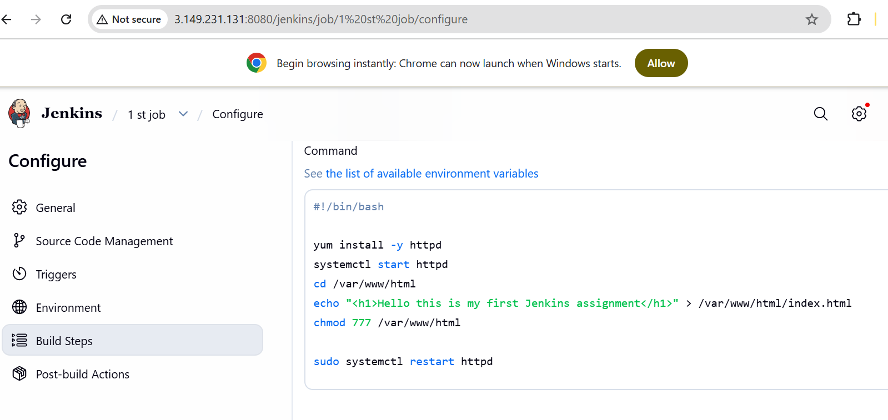
- Apply and save run build and check the status
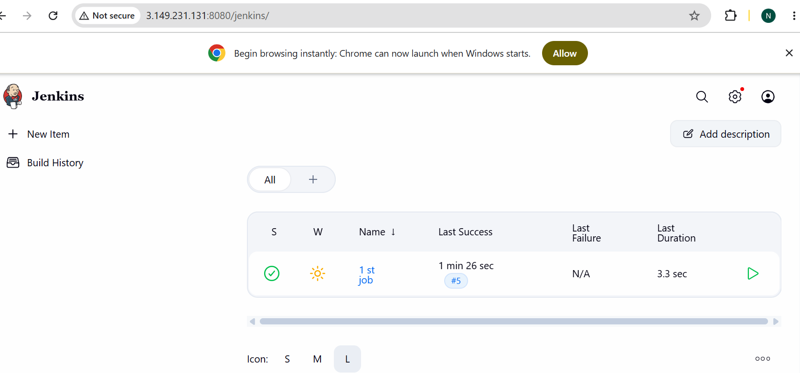

- Access it with http local host
- Add 8080 -Custom tcp and Http – 80 in SG
